**Step 1      Menu Keys I-F-4**

First, create new Warehouses via I-F-4

Create a Separate Warehouse for Each Customer Location.

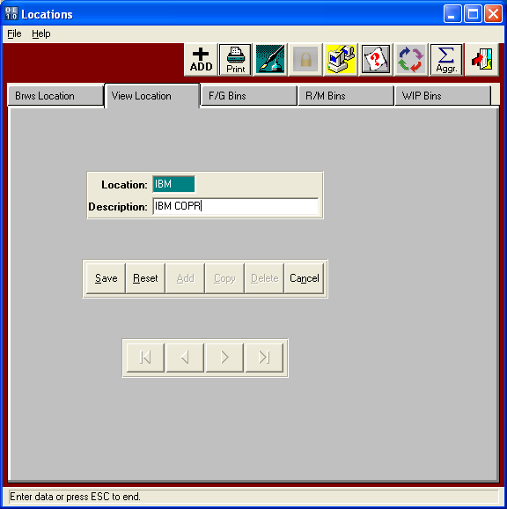

STEP 2       Menu Keys I-F-4   F/G Bins Tab  
Add a Bin Location for each Warehouse that you created in step 1.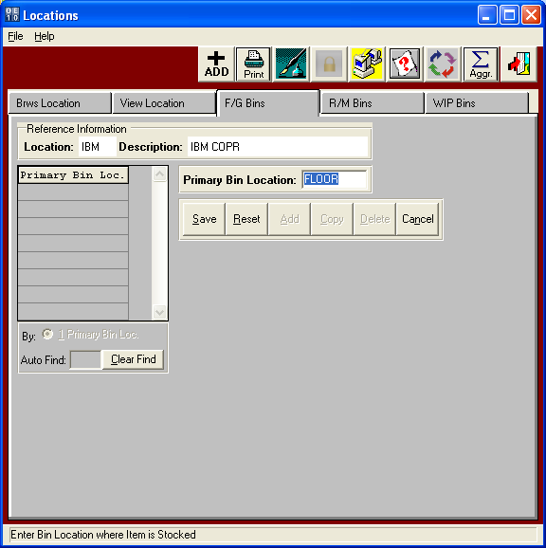

STEP 3       Menu Keys A-F-8

You must create a Carrier for the New Warehouse.  Sorry, but its required in Shipto File.

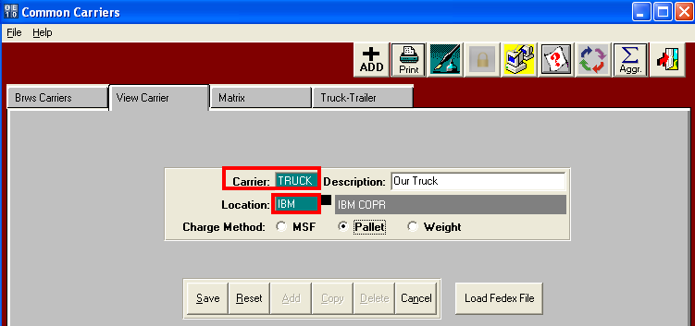

STEP 4       Menu Keys A-F-8  Matrix Tab

You must create a Matrix for the Shipping Truck/Carrier for the New Warehouse.

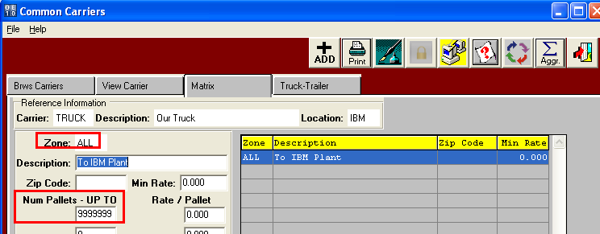

STEP 5       Menu Keys A-F-1  Customer File

Add / Find your Company as a customer under A-F-1

This must have status = X

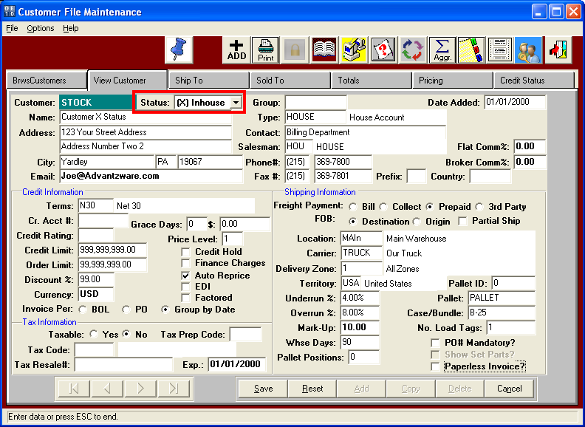

STEP 6       Menu Keys A-F-1  Ship To Tab.

Click the SHIPTO Tab for your Company

Add the new Shipto Locations for your Customer.

You must include the new Warehouse and Bin in addition to the Address.

This is the key.

The new warehouse created in Step 1 is the warehouse that Finished Goods will transfer to when the Bill of Lading is posted.

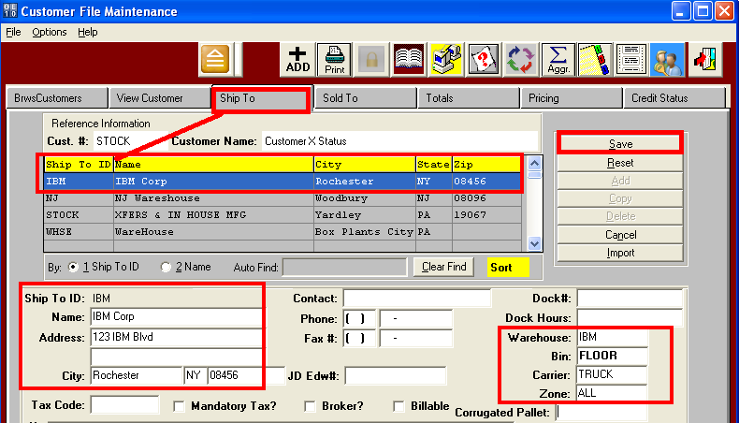

STEP 7       Menu Keys O-U-1  Creating TRANSFER via Release Tab.

To Ship the Goods to your Customer.

Find the Order and click the RELEASE tab.

Add release with Status = T for Transfer.

Then Press F1 on the Shipto and select the Customers Shipto Location from your Customer Shipto File.

This will transfer to the Bill of Lading and Move the FG items to that Warehouse Location.

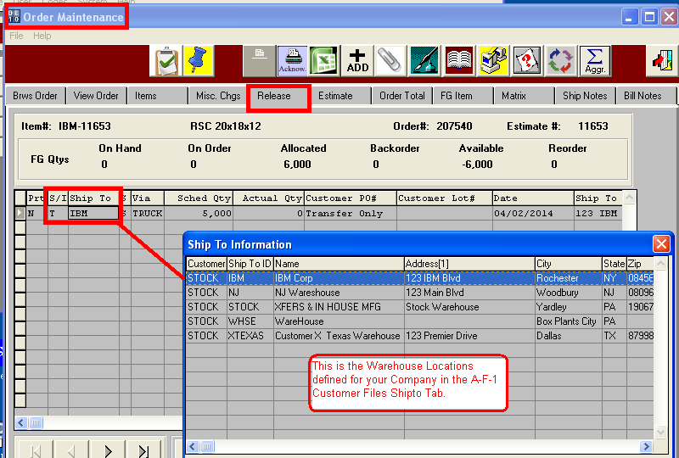

STEP 8       Menu Keys O-U-1  Release Tab / Release Button

Release the Item and create a Bill of Lading via your Normal Operating Procedures.

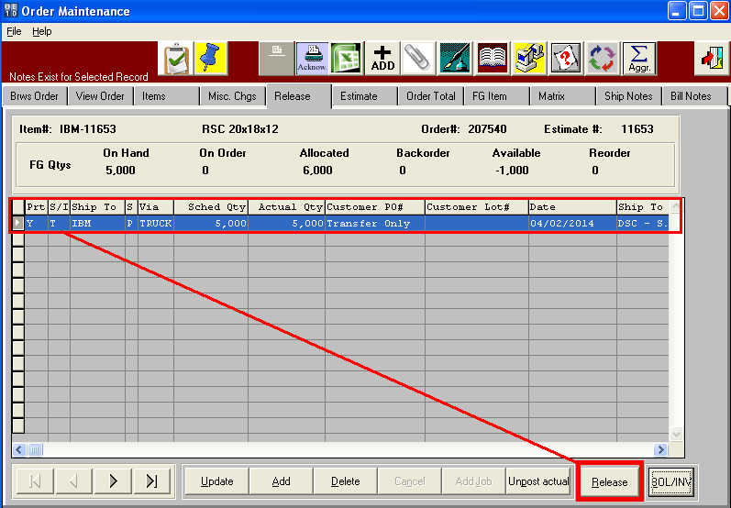

STEP 9       Menu Keys O-S-1  Bill of Lading

When the Shipto has the Correct Warehouse defined in the A-F-1 Shipto To file.    
The FG Boxes will transfer to that Warehouse when the Bill of Lading is Posted.

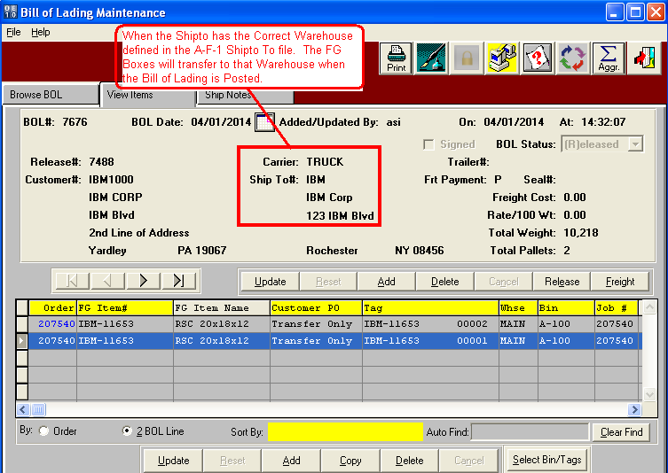

STEP 10     Menu Keys I-U-2  Finished Goods Transfers

When the Bill of Lading is Posted, the Finished Goods will be transferred to the Warehouse Location on the SHIPTO File.

In this example, the shipto IBM will transfer to the IBM warehouse.

Advantzware logic for TRANSFER releases will bypass the invoice and create a Transfer Transactions.

This must be posted via I-U-5.

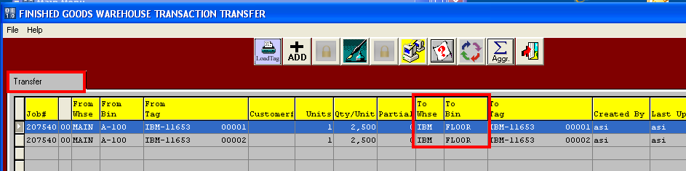

STEP 11     Post Inventory Transfers

When I-U-2 Transfers are posted, the inventory on hand is then displayed in the IBM warehouse.

This step must be done, the question is when.

Either via Bill of Lading or transfers can be manually added via Sharp Shooter Transfers.

For Customer transfers for Consignment, the Integer Value should be set to 0.

When posting the Bill of Lading, the N-K-1 BOLPost Integer value dictates the Transfer Logic.

Integer Value = 0 will post goods immediately to I-U-2.

Integer Value = 1 will not create transfers.  This must be done as an extra step via Sharp Shooter.

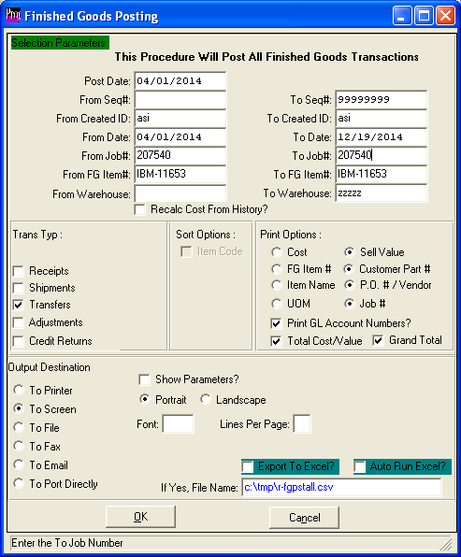

STEP 12 Invoicing Customer.

When invoicing customer.

On O-U-1 Release Tab. Add release for type B for Bill and Ship as a normal release steps.

Release Items.

Create Bill of Lading (This will Ship From the IBM Warehouse)

Create Invoice

Notice the BOL tab on the Invoice will show the Bill of Ladings Ship from the customers Warehouse IBM.

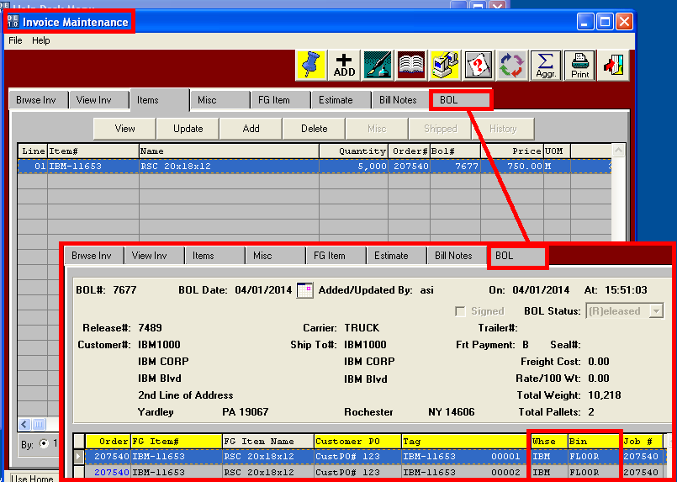

STEP 10  Special Notes on Step 10 N-K-1 BolPost Integer Value

When posting the Bill of Lading, the N-K-1 BOLPost Integer value dictates the Transfer Logic.

Integer Value = 0 will post goods immediately to I-U-2.

Integer Value = 1 will not create transfers.  This must be done as an extra step via Sharp Shooter.

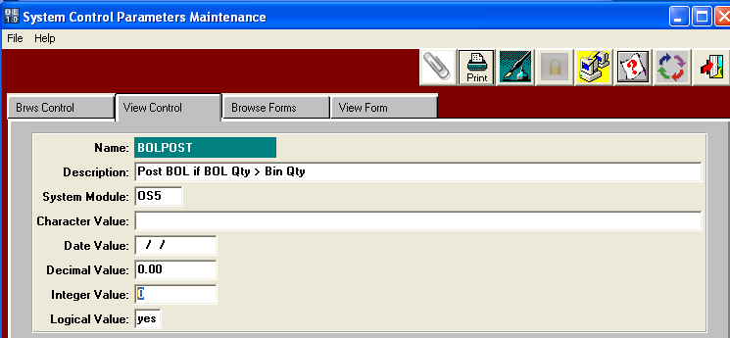

**Integer Value = 0  This will create a Transfer under I-U-2**    
Posting Bill of Lading will create finished goods transfers to the I-U-2 transfer screen.   
The transfer must then be posted via I-U-5 to update inventory.   
In reality, pallets are sitting on a truck and not in the receiving warehouse until received by the warehouse clerk at the delivery location.  For clients using Sharp Shooter, this gets tricky when shipping partial pallet with bar coded pallet tags.  A pallet tag can only have 1 location,

therefore a partial tag posted via the bill of lading will immediately create a new load tag for the partial quantity for the new location. The Problem with this logic is that the Original Tag must be Scanned and listed on the Bill of Lading.  And the new tag is not created until the BOL is posted.

Therefore, the new BOL must be posted and then the new Load tags Printed.    
If the Pallets are already packed on the truck, they cannot be attached to the pallets.

Therefore, Integer Value = 1 may be a better option for Sharp Shooter Clients.

**Integer Value = 1  This will not create a Transfer under I-U-2**

For Sharp Shooter Clients, this is the better option.

When posting the Bill of Ladings, transfers for finished goods to the I-U-2 transfer screen WILL NOT be created. The Bill of Lading will be considered posted but no inventory transactions will occur.    
The Original Pallet Tags listed on the Bill of Lading will continue to be located in the Original warehouse.    
An external receiving warehouse will then create a transfer via Sharp Shooter when the truck arrives by scanning the Original Pallet Tag.  When Posted, the Location will be updated for each pallet Tag.  Please Note, for clients using Sharp Shooter, this gets tricky when shipping partial pallets with bar coded pallet tags. For partial shipments of Tags, a copy of the original tag# must be made and applied to the partial pallet.    
Therefore, the same identical Pallet Tag# will be attached to the original pallet location and also on the Truck.    
When the truck arrives, the forklift driver click the TRANSFER button and scan the original bar coded pallet tag.  The Sharp Shooter software will then prompt to create a new Pallet Tag for the transferred quantity.   
When this transaction is posted, on hand balances for both original Tag and newly created tag will simultaneously be updated. Why?  Because a pallet tag can only have 1 physical location.

Since Sharp Shooter Transfer logic creates new Pallet Tags, the Receiving Clerk, must PRINT the New Tags.

Then Attach to the new Pallets as part of the Transfers Receiving Process for the new location.

Sincerely,

Joseph Hentz, President

*ASIlogo*

*301 Oxford Valley Road, Ste 1713*

*Yardley, PA  19067*

*Office Phone 215-369-7800*

*PA Office Fax 267-503-0226*

*SC Office Fax 843-357-4365*

*Cell Phone 215-479-5561*

*Website:* [*www.Advantzware.com*](http://www.Advantzware.com)

*Email:* [*Joe@Advantzware.com*](mailto:Joe@Advantzware.com)